**Project Name : Travel & Tourism Website (Wardha Tourism Website)**

**Wardha Tourism Website Documentation**

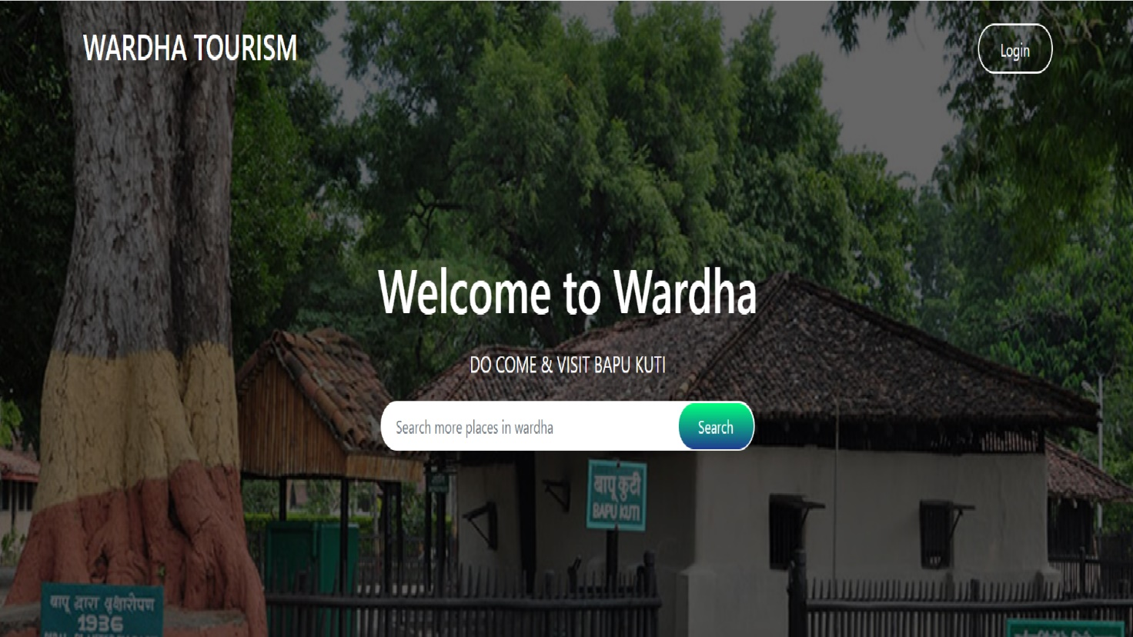**Home Page**

*Development by Pritam Dhande*

*Intern at Edureka! (Batch : 38)*

# Overview

Wardha Tourism is Tourist Guide Platform for provide valuable information related tourist places in Wardha and other useful information about Wardha District.

# Website Pages:

* Home Page
* Places Page
* Gallery Page
* Blog Page
* About us Page
* Contact us Page

# Technologies used in Wardha Tourism Website:

**Front-End:**

1. Html
2. CSS
3. Bootstrap
4. JavaScript
5. React JS

**Back-End:**

1. Node JS
2. Express JS

**Database :**

* MongoDB

**Code Editor Used:**

* Visual studio code

**Version Control System:**

1. GitHub
2. Git Bash

8pGit Hub link - https://github.com/Pritam-Dhande/Second-Project-Document